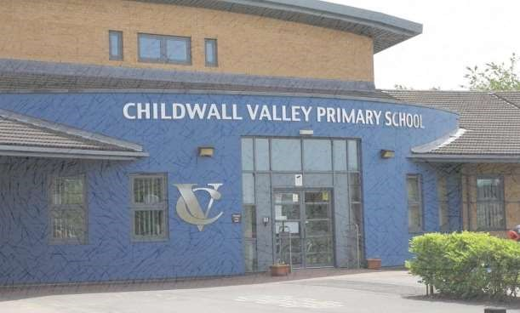

Welcome to Childwall Valley Primary School

A big welcome to Childwall Valley Primary School!

We are very eager and excited to meet you. Within this Parent Pack you will find information about our school, transitions and all of the educational programs, websites and apps you can access from home.
If you would like any further information please do not hesitate to contact us.

Ms Thomson,
Childwall Valley Primary School,
Craighurst Road,
Liverpool,
Merseyside,
L25 1NW

0151 722 2544

Email:enquiries@childwallvalley.org

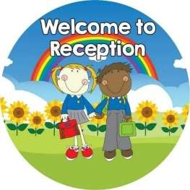

The Early Years Foundation Stage is made up of our Nursery and Reception classes. We work closely together with parents and carers to provide a caring and stimulating learning environment and to meet the needs of each individual child.

Our Foundation Stage is a happy, positive start to their school life.

Our aims and expectations at CVP are to create an environment where your child feels safe and secure and are encouraged to take charge of their own learning.

Children are valued and seen as equal partners, we see children as both teachers and learners. We wish to develop confident independent and competent creative children, who are inquisitive and persistent.

Head Teacher: Mr Keher | Acting Deputy Head: Mrs Hoos
Chair of Governors: Cllr Murray | EYFS Lead, Reception Teacher & SENDCo,  SEMHWB Lead: Mrs Merrison
Nursery Teacher: Miss Roberts | Business Manager: Miss Thomson
Nursery Teaching Assistant & Breakfast club:  Mrs Brand | Reception Teaching Assistant: Mrs Coltherd

Information for Parents

The Early Years Foundation Stage Curriculum
Development Matters

There are seven holistic areas of learning and development in the EYFS.
This is broken down into Prime and Specific areas.

Prime  Communication and Language  Listening, Attention  Understanding  Speaking  Personal, Social and Emotional  Self-Regulation  Managing Self  Building Relationships  Physical  Gross Motor  Fine Motor | and |  | Specific  Literacy  Comprehension  Word Reading  Writing  Mathematics  Number  Numerical Pattern  Understanding the World  Past and Present  People, Culture  Community  Natural World | and
Expressive Art and Design
Creating with Materials
Being Imaginative and
Expressive

Children and Staff take part in planning meetings, we listen to children’s play and parental contributions to decipher what topics to teach. The above 7 areas are used to plan for your child’s learning and activities along with the Characteristics of Effective Teaching and Learning.

The Development Matters is suitable for our young children, and it's designed to be flexible so that we can follow your child's unique needs and interests. Children in the EYFS learn by playing and exploring, being active, and through creative and critical thinking which takes place both indoors and outside.

Uniform:
At CVP our uniform can be purchased from Lisa’s School Wear on
East Prescot Road or Kitted Out on Allerton Road. Please see attached information sheet.
Our school uniform for Reception consists of:
● White polo shirt
- School jumper/tank top/Cardigan
- Black trousers/shorts/skirt
- Black shoes – velcro fastening
- Pair of wellington boots to be kept in school and labelled
- School book bags – to be brought to school daily
- Summer term only – Navy summer dress
PE Kit
- Shorts & T-shirt with school logo
- Black pumps
- All to be placed in a PE bag

Our school uniform for Nursery consists of:
- White polo shirt
- Navy school badged sweatshirt
- Navy school badged jogging pants
- Black pumps
- Pair of wellington boots to be kept in school and labelled
- Summer only – Black cycle shorts instead of jogging pants

Please ensure all clothing is labelled clearly.

Tapestry (Nursery and Reception):
Evidence is gathered through on-going assessment throughout the year and through continuous consultation with parents and carers.
Assessment is gathered through observing children and recording their achievements. We ask parents to contribute to their child’s achievements through the tapestry app. Please see additional letter.

Busythings:
Please access www.busythings.co.uk to play on educational games including maths, literacy, creativity, understanding the world and ICT that will support your child’s learning.

Login
Username: cvp101 Password:fos101
Breakfast Club:
Reception children are able to attend Breakfast club. This runs from 8.00am -8.45am and is £3 per child per day. Places can be booked on our booking system https://childwallvalley.schoolcloud.co.uk

Snack:
Children are provided with milk (up to their 5th birthday) or water, a piece of fruit and a light snack each day, which they can access themselves at the snack station. We do encourage independence by using and washing cutlery and cups.

Foundation stage children should not bring water bottles in as they are encouraged to use the water station to promote independence within health and self care.
We ask for a contribution of £2 a week towards snack, baking and play dough making as well as lots of other exciting activities. You can pay this weekly or termly.

Medicines:
If your child needs to take medication prescribed by their GP in school, a form must be completed. Please ask at the school office.

Absences:
If your child is absent from school please telephone and leave a message in the pupil absence inbox to let us know. If you do not contact us you will receive a phone call from us.

After School Clubs:
Any after school clubs you would like your child to attend should be booked our online booking system https://childwallvalley.schoolcloud.co.uk

Website and Social Media:
We keep our website regularly updated with letters, information and events. We showcase children’s learning trips, visitors, general every day school life and messages on Twitter, Instagram and Tapestry. Parent letters will be published in the Parent section of our website under Parent Letters www.childwallvalley.org/letters-home/

You can keep up with our school events on Twitter (@ChildwallPri) and we send out Good News Texts daily.

Reception Twitter: @CVP_Reception
Reception Instagram: CVP_Reception
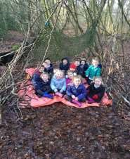
Topics and Educational Visits:
We provide a balanced, exciting and challenging curriculum and go on trips as much as we possibly can. We use our observations, discussions with the children and use play as the vehicle for learning. At CVP we cater to the children’s interests and involve them in the planning process to ensure free flow learning and engagement of the children.

We have four school mini buses and utilise our local area as well as wider Liverpool as often as we possibly can. You will need to fill in a permission slip form at the start of the school year.

Forest School:

We have such an amazing opportunity here at Childwall Valley. All children in Nursery and Reception take part in bush craft and den
making during our weekly forest school sessions.
During the course of the year the children will take part in a variety of shared experiences and develop skills which will include: studying wildlife, playing team and group games, communication/friendship activities, sensory activities, phonics activities, physical movement, rope and string work, art and sculpture, developing stories and drama, shelter building, tool use, woodland and traditional craft, fire lighting and cooking.
The children will explore our sensory world and will develop their gross and fine motor skills as well as their strength, co-ordination and positional awareness. They will have opportunities to develop their core strength, stability, balance, spatial awareness, co-ordination and agility. They will have opportunity to develop fine motor control and precision whilst developing their hand-eye co-ordination.
They will have the opportunity to practice using small tools which allows children to develop proficiency, control and confidence all whilst having FUN!

Phonics and Reading:

At CVP Phonics is immersed into everything we do. We use systematic synthetic approach using Read Write Ink. In reception this means your child will first learn a small group of sounds associated with written letters.

We provide every opportunity to support children develop their early reading skills.

From Reception, the children learn to read using a wide range of decodable books that will captivate their interest. Children take home decodable books linked to what they have been taught in school.
A Home Link Book will be sent home which reinforces home/school relationships. Parents are encouraged to write their personal comments in this book, regarding the child’s reading. We encourage parents to celebrate their child’s learning and support them in developing their fluency and comprehension when reading with them.

Maths:

Just like Phonics, Maths is also immersed into everything we do at
CVP. We use mathematical language in everything we do from baking to writing our shopping lists in the home corner.
We use the subitising approach and we ensure each child has an understanding of number, linking names of numbers, numerals, their value, and their position in the counting order. Children will understand numerical patterns.

Attendance:

At Childwall Valley we expect a good level of attendance which equates at least 97%, we do not authorise holidays in term time, medical appointments are ideally to be made at the start or end of the school day with evidence to be provided to the school office.
If we are concerned about your child’s attendance you will be invited for an attendance meeting. You can find more information regarding this on our school website within the attendance policy.

ROAR:
We are so happy and excited that we have implemented ROAR, a Response to Mental Health in Primary schools from Nursery to Year 6 and this is very much a whole school and wider community response.

At Childwall Valley we believe the whole-school approach to mental health is paramount and so our behaviour policy has been implemented which compliments the ROAR Response.

We have completed whole staff training to ensure ROAR practices are delivered by ALL staff in and around our school throughout the day.

“Mental health is all about how we think and feel about ourselves, others, and the world around us. We ALL have it.” RAOR Handbook
What is ROAR?
The ROAR response to Mental Health in Primary Schools allows teachers and all staff to recognise and address the signs of mental health in children. It is a first line response aimed at equipping front line professionals with the tools to provide early intervention, and support to children experiencing mental distress.
ROAR also recognises the importance of building resilience in children. The ROAR response offers education in building resilience in relation to specific mental health needs. It also helps to spot the signs and symptoms of a child experiencing concerns with their mental health.

ROAR Rainbow:
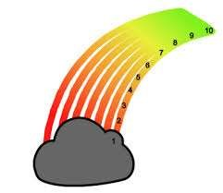
At CVP our ROAR Rainbows are seen around our whole school, staff wear them on their lanyards and each class has implemented a ROAR rainbow where children can move themselves up and down the rainbow during the day. This way we can see if anyone has gone down or up the rainbow at all and we can address it. This is used at various intervals: if a child arrives late by the office staff, before and after using the calm down boxes, when dealing with behaviour situations, when a child comes back from their counselling sessions, if they seem lonely, or when dealing

with SEMHWB around the school, this is always dealt with sensitively and discreetly.

We have implemented a number system across the school and we would expect the children to be answering the register using the number system on the ROAR Rainbow. The children give a number or if they don’t want to, they just answer their name as usual. If the children are a 7 or below an adult will take the time to have a conversation with this child.
We recognise it is important that adults in the classroom share their numbers too and to be honest with the children. If you’re a 6 because you’re a little tired, or have had a chaotic morning, that’s ok! Children need for us to model the scale accurately and know that being a low number is not a ‘bad’ thing. The more we model all kinds of mental health to children, the better.
Most of all at CVP we do not disregard children’s feelings when discussing numbers- e.g. if children are giggling and making jokes and saying they’re a 1, it is easy to disregard their number. Bear in mind some are good at hiding their true emotions. It may be that they don’t understand the scale yet or they are hiding true feelings. We take the approach that low numbers are not just ‘attention seeking’. Children may really be struggling and they’re giving us a clear sign that they need our help.

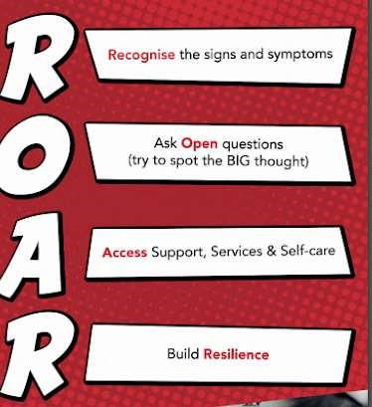

What are we as a School doing differently?
- As well as our new ROAR Project our School has taken part in the Trailblazer Project through Liverpool Learning Partnership. We have an external Education Mental Health Practitioner who works with referred children who are living with with Social, Emotional, Mental Health and Well Being issues.

- We have 2 Social Emotional Mental Health and Well Being Leads in school, Mrs Merrison and Mrs Rawstorne who work with our growing number of practitioners to support children and parents
SEMHWB.

- We have previously and still do offer Seedlings sessions, these sessions are in school half a day a week to work with children living with SEMHWB needs.

- We have built up a partnership with Brighter Horizon’s and have a councillor come into school once a week for half a day to support children living with SEMHWB.

- We have a new partnership with the ADHD Foundation to work with groups of children to support their learning for children who have ADHD or ASC.

- We have implemented sensory breaks throughout the day for children with sensory needs.

- Play leaders will be leading games at break and lunchtime to provide happy experiences

What can you do at home to help?

Programme for Schools Promoting Alternative Thinking Strategies (PATHS):
At CVP we use PATHS. This is techniques promotes self-esteem and self-confidence. There are 4 puppets and story books to help the children to understand the techniques.
Each day a child is chosen to be ‘PATH
Child of the day’ peers will give complements to this child and this will be sent home for parents to add to.

Induction procedures:
We aim to provide a smooth and successful induction for your child coming into school.

Stay and Play:
There will be a Stay and play session before Nursery and Reception begin school in September. Further details will follow.

School Meals:
Children in Reception have a meal provided by school. No pack lunches are allowed in school. Please find attached a three-week menu.

Pupil Premium:
If your child is eligible for Free School Meals school can receive additional funding known as Pupil Premium. Please complete the attached form and return to the school office.

School start and finish times:
Your child will start school at 8.45am and finish school at 3pm. Reception and Nursery children are to enter and be picked up through foundation door situated on the main playground.

Dropping off your child:
We understand this is a big journey for your little children. We aim to make them feel as comfortable and confident as possible whilst helping children become independent learners therefore we encourage every child to enter school, on their own. As soon as your child is ready please encourage them to enter school independently.

Update Information:
If your child’s medical needs change or you need to update your contact telephone numbers or email, please use the parent app or contact the school office. It is very important we have at least two contact numbers for use in case of emergency.

If you have any questions please do not hesitate to contact us.
Mrs Merrison
Reception Teacher / EYFS Lead

Miss Thomson
School Business Manager

Mr Keher
Head Teacher

0151 722 2544 enquiries@childwallvalley.org

