A Parents’ Guide to Read Write Inc. Phonics.

At Childwall Valley, we use the Read Write Inc. (RWI) programme as a method of teaching reading and writing. Read Write Inc. Phonics teaches children to read accurately and fluently with good comprehension. They learn to form each letter, spell correctly, and compose their ideas step-by-step.

Children will:
- Learn 44 sounds and the corresponding letter/letter groups using simple picture prompts
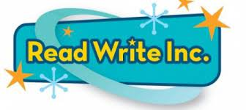
- Learn to read fluently so that they can focus on understanding what they read
- Learn to read words using Fred Talk
- Learn to read words by blending the sounds together
- Learn to write the letters/letter groups which represent the 44 sounds (graphemes).
- Spell fluently so that they can focus on what they want to write
- Learn to write words by saying the sounds in Fred Talk
- Learn to write simple and then increasingly complex sentences

What is Fred Talk?
We will introduce your child to a toy frog called Fred when children are ready to start reading words.
Fred can only say the sounds in a word and needs your child to help him read the word. Fred will say the sounds and children will work out the word. For example, Fred will say the sounds c–a–t, and children will say the word cat. This is Fred Talk: sounding out the word.

Blending
Children learn to read words by blending the letter sounds that are in the Speed Sound sets. Help your child learn to read words by sound-blending e.g. c-a-t = cat. Help children to say the pure sounds, as quickly as they can and then to blend the sounds together to say the whole word, here is a link to help you with the sounds https://www.oxfordowl.co.uk/for-home/reading-owl/find-a-book/read-write-inc-phonics--1/phonics-pure-sounds-video

Set 1 sounds Set 2 sounds Set 3 sounds
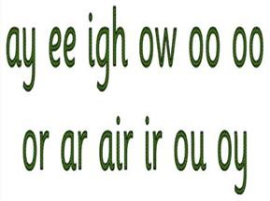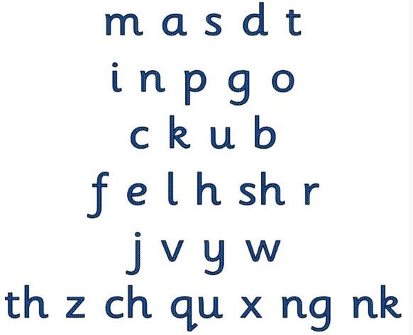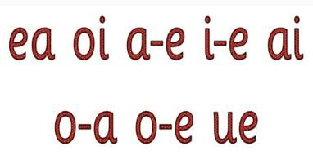

To help children with their writing, we use the following rhymes to help them to remember the correct letter formation. It would be most helpful, if you wish to support your child at home with their writing, if you also referred to these rhymes.
